Quiz 3 Environmental Biology 104 Summer 2021
Modules 5 & 6
102 points possible

READ THESE DIRECTIONS AND COMMENTS BEFORE TAKING THE TEST!

- Answer as clearly and concisely as you can. (Lists and bulleted points are acceptable). Please keep the text of the test with your answers.

- Put your answers in BOLD or in COLOR to keep them separate from the questions.

- Use your own words to answer the questions.

  - Since access to material cannot be controlled, this test is “open book” which means you may look at the Reading Assignments and Course Contents (Module Information) as you work on the quiz.

- This test must be turned in by midnight EST on Monday, July 19th.

Module 5 – Chesapeake Bay (CB) 52 pts

1. A. Define Estuary (2) – Estuary refers to the point where freshwater rivers and the ocean meet. Depending on the shape, size, depth or amount of freshwater among other physical conditions, estuary can also be called a bay, harbor, inlet or sound or slough.

B. True or False. Chesapeake Bay is the largest estuary in the United States. (1) True

C. How large is the Chesapeake Bay watershed? (1) 64,000 square mile

D. Which states (and district) are found within the CB watershed? (2)

(6 pts) Among the states found in the Chesapeake Bay watershade are
- New York
- Maryland
- Virginia
- West Virginia
- Pennsylvania
- The District of Columbia and Delaware

2. From the food web diagram in the “Food Chain Structure” section: (5 pts)

A. List the 3 major sources of inorganic nutrients to producers within an estuarine system. (3pts) The sources of inorganic nutrients to the producers include river delivery, ocean water influx with the tides and the recycling of nutrients by the decomposers living in the estuarine community.

B. Put the following terms in a correct cycle: producers, decomposers, inorganic compounds, organic compounds. (Since it is a continuous cycle, you may start with any of the terms, but you must put the remaining terms in the correct order.) (2pts). (Your answer should have this format: Starting term flows to second term flows to third term and then goes to fourth term which goes back to starting term.)
Inorganic Compounds - Producers – organic compounds- Decomposers- Inorganic Compounds

3. A) There are two main reasons that most estuaries have high biodiversity. What are those two reasons? (2pts)
The high biodiversity in estuaries is due to the varying abiotic factors that is; the salinity of the water and the exposure of the habitat to sunlight as well as dissolved gases. Different species will occupy different parts of the estuary system depending on these two factors.

B) True or False. In a specific area of the bay, abiotic conditions will be almost constant from day to day during a particular season. (1pt) False

C) The salinity of the water within the bay varies along the length of the bay. Give typical salinity for the upper parts of the bay 0.5 ppt and for the mouth of the bay 24-30 ppt. (2pts)

D) What natural event could cause an overall depletion of the salinity of the bay? (1pt) Extreme storms or droughts

E) Dissolved gases in the waters of the bay vary more B (1pt).
(Choose one: A. across the width of the bay or B. along the length of the bay)

(7 pts Total)

4. List 4 actions mentioned in the Module 5 content that farmers that live within the CB watershed can do to limit negative agricultural impacts on the waters of CB.
(4 pts)
To limit negative impacts on the waters of CB due to agriculture, farmers can implement the following strategies
- They can implement rotational grazing to control overgrazing that leads to soil erosion which pollutes CB waters
- Farmers can reduce nutrient levels in animal feeds through precision feeding of livestock. In turn this will reduce the nutrient levels in manure that sometime runoffs into the CB waters
- They can also plant cover crops between a filed planted with cash crops. This helps to hold the nutrients
- Alternatively riparian buffers between fields and streams can be used to filter nutrients before they enter the water

5. What are three (distinct) major threats to oyster populations within CB? (3pts)
The three major threats to oyster are;
- Reduction of water quality
- Alteration of their habitat
- Overharvesting of the oysters

6. Water Quality of the Chesapeake Bay

A. List 4 major factors that have caused the reduction in water quality within CB.
(4pts)
Water quality in CB waters has been reducing due to
- Loss of Oysters due to overharvesting
- Agricultural practices
- Loss of marshland and
- Wastewater production and treatment

B. List three consequences (results) of reduction in water quality within CB.
(3pts)

Reduction in water quality leads to
- Growth of harmful algal blooms
- Loss of seagras beds and
- Development of anoxic areas also known as dead zones
C. In your opinion which of the above is the most serious consequence (result)? __________________ Explain why.
(This is an opinion question…you won’t find a “correct” answer in the content. You just need to tell me what you think and explain your reasoning.). (2pt) In my opinion, the most severe consequence is the growth of harmful algal blooms. This is because the impact of growth of harmful algae are multiple as compared to the impacts of the other consequences. For instance, algae blooms produce toxins that can kill aquatic life, contaminate shellfish and in some cases it may harm fishermen and people living along the coastalline. In addition, algae bloom lead to hypoxia and anoxia of the bottom water

D. Explain why the loss of oysters is a CAUSE of reduction in water quality. (1pt)
(10 pts Total) Water Oysters filter feed and in the process they remove edible algae and inedible sediment that may otherwise reduce the water quality. In the 1700s there were many large oysters in the waters of the bay. Many oysters and large oysters meant that the entire water body would be filtered through oysters every 3-4 days. However, due to overheating and diseases the numbers of oysters have been declining. Moreover, the oysters left in the waters are no longer as large as they were. As such, currently, it takes at least a year for the water in th bay to be filtered through Oysters. These means that there is accumulation of organic material, planktonic algae and sediments I the unfiltered water, which reduces the quality of water

7. Marshes and other communities near the bay physically “protect” the aquatic environment in different way. List 3 distinct ways through which the protection occurs. (3 pts)
Marshes and other communities protect the aquatic ecosystem by
Forest and marshes near the shore increase infiltration of water into the soil therefore preventing the rapid changes in water delivery into the bay.
During heavy rains that cause floods, salinity levels in the water tend to surge causing stress to the aquatic life. However, marshes and other communities come in handy since they help to prevent flooding into the water.

8. A. Name two invasive species (discussed in the Module’s content) that are
threatening CB. (2pts) Mute Swams and

B. Explain the damage that each of these organisms does to the bay. (2pts)

Mute Swarms- One Mute Swarm can consume up to 20 pounds of submerged aquatic vegetation. These species is a threat to native aquatic plants. Other than that, Mute Swarms are known to be aggressive especially when nesting or brooding. Therefore, they often chase of and sometimes kill native waterfront species.

9. Module 5 Reading Assignment #2.
https://www.cbf.org/about-the-bay/state-of-the-bay-report/index.html
All the below answers should come from the reading and not from other sources. (7 pts)
- In 2020 what was the average health index score of the bay? 32 pts out of 100. (1)

- Pollution, Habitat and Fisheries are the 3 major categories for the indicators of bay health. List the 4 individual indicators within each category. (3)
(You must list all of the correct indicators in a category to earn the point) Pollution
- Nitrogen
- Water Clarity
- Dissolved Oxygen
- Toxics
Habitat
- Resource Lands
- Forrest Buffers
- Underwater grasses
- Wetlands
Fisheries
- Shad
- Oysters
- Rock fish
- Blue Crabs
- What was the main reason why the score for the Bay from 2018 to 2020 reduced by one point? Explain why this occurred (There are three main reasons). (3pts) The health score of the Bay reduced due to ineffective management leading to
Pollution, change in habitat and the overexploitation of fisheries

10. Module 5 Reading Assignment #1: https://www.chesapeakebay.net/news/blog/chesapeake_bay_blue_crab_population_remains_healthy_and_sustainable_despite

Summarize the status of the blue crab population in Chesapeake Bay in 2020 by answering the following questions:

  - What was the change in population size from 2019 to 2020? From 55 to 60
  - Is the population being overfished? Yes
  - What do they think caused the wintering mortality of juveniles between 2019 and 2020 to be low? Due to global climate change which has affected breeding habitats

(3 pts)

Module 6 – Great Lakes (GL) 50 pts

1. The abiotic conditions found within a lake are determined largely by three or four factors. List at least three of those factors. (Note: I’m NOT asking for the abiotic conditions within the lake) (3 pts)
- The abiotic conditions within a lake are affected by
- The climate of the area
- The geology of the land surrounding the lake
- The shape and size of the lake

2. A. List the 4 zones found in large lakes. (4pts)
- The Littoral zone
- Limnetic
- Profundal and the
- Benthic zone

B. Which of the above zones would always have low light levels? (Be careful with this one; there is only one right answer.) (1pt) the profundal zone

- List at least 4 abiotic factors that often vary between the surface and the depths of a deep lake when the water column is stratified. (2 pts)
- Temparature
- Dissolved gasses
- Light
- Water Regime

(7 pts total)

3. A. List the names of the Great Lakes according to size (Use volume not surface area, for size determination). (2.5pts)
- Lake Superior
- Lake Michigan
- Lake Erie
- Lake Huron
- Lake Ontario

B. Which Great Lake has the longest retention time? (1pt) Lake Superior

C. Which Great Lake has the shortest retention time? (1pt) Lake Erie

D. Approximately, how large is the watershed for the entire Great Lakes? (1pt) 96000 sq mi

E. Name the three Great Lakes that have experienced the greatest increase in human population in their basins over the last 100 yrs. (1.5pts)

(7 pts total)

- Lake Erie
- Lake Ontario
- Lake Huron

4. From the “Why are the Great Lakes Great?” section – Land Use Diagram: (8 pts)
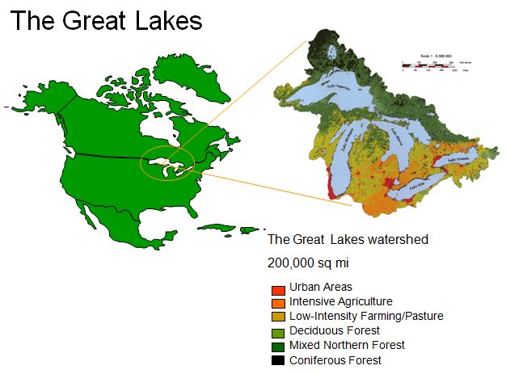
A. List 3 different land “uses” seen in the watershed of the Great Lakes.[Note: There are 6 designations on the diagram but some of them are similar to each other.] (3)

- The land uses include
- Agriculture
- Development of urban area
- And growth of forests

B. List the 3 main threats to the Great Lakes that were described in the module content. (3)
- Pollution
- Change of global climate
- Numerous Invasive species

Out of the three, which do you see as the most serious? __________ Explain your answer. (This is an opinion question…you won’t find a “correct” answer in the content. You just need to tell me what you think and explain your rationale.) (2) Pollution is the most serious threat to great lakes. This is because, first pollution can be caused by a wide array of things including pathogens, sediments organic or inorganic chemicals among others. In addition the impact of pollution is felt in the reducing the water quality, leads to decline in productivity, habitat destruction and change in both aquatic and non-aquatic species

5. Module 6 page 11 “More recent and current issues” - From chart (bottom) “Major Water Pollutants and Their Sources and Their Impacts”.
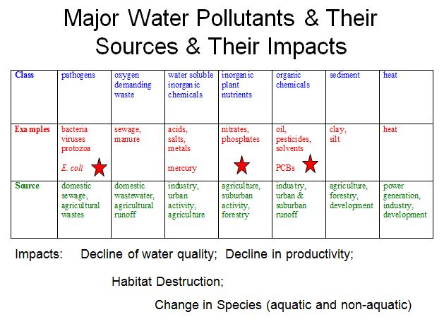
A. List 6 classes of pollutants that are found in the Great Lakes. (3)
- Pathogens
- Sediments
- Inorganic plant nutrient
- Water Soluble inorganic chemicals
- Oxygen demanding waste
- Heat

B. Name 3 specific examples of pollutants that come from industrial sources. (1.5)

- Metals
- Mercury
- Dioxins
C. Name two sources of pathogens found in the Great Lakes. (1)
Sources of pathogens include
Untreated sewage and storm water run off

D. Name one source of heat pollution in the Great Lakes (0.5)
(6 pts)
Cutting of trees which reduced shading on the water masses exposing them to sunlight leading to rise in temperatures (heat) in the water.

6. Bioaccumulation (5 pts)
A. Explain in detail how certain animals can have extremely high concentrations of a toxin within their systems even though the level of that toxin in the environment is very low. (2)
When chemicals are not metabolized by the organism they tend to accumulate in the tissues of the organism since they are fast soluble. When organisms at the bottom of the food chain absorbs these chemicals they accumulate in higher levels of the food chain. These chemicals are passed through biomass. So that at the end the organism at the top of the chain has more chemical levels than that in the water. This process is known as bioaccumulation.

B. Why do some toxins bioaccummulate and others do not? (2)

Persistent chemicals bioaccummulate while chemicals that are not persistent do not.
C. As a terrestrial organism, how do humans get affected by these toxins that are found in aquatic environments? (1)
Bioaccumulated toxins settle into the soil and after some years they get resusupended as sediments. Due to the sediments fishes are degraded and there is a numerous number of invertebrate population. When humans consume these fish they put their health at risk

7. List 4 possible ways in which transport of invasive species by ballast water of ships can be prevented.

(2pts)
Transportation of invasive species through ballast water can be protected through
- Implementation of regulations like the exchange of water mid-oceans before entering Great Lakes
- Water treatment through use of biocides
- Filtration
- UV light exposure
- Use of acoustics

8. What are two major ways in which the challenge of remediation and conservation of the Great Lakes region differs from the challenge of remediation and conservation of the Chesapeake Bay. (4 pts)

Unlike in the restoration of Chesapeake which the community has agreed to work together, one of the challenge of the remediation of Great lakes is the lack of the community agreeing to work together

The remediation of the Great Lakes involves the federal state unlike for the Chesapeake which only involved individuals like politician and conservationists.

[Note: This concept was not stated specifically in any of the module content or reading assignments. Consider what you know about each ecosystem and its problems and then state a couple of differences. I do have two specific differences that I am looking for but as long as your differences are relevant and accurate and different enough from each other then you will be given credit for your answers.]

9. There are many Areas of Concerns (AOCs) within the Great Lake watershed.
Thoroughly explain what an AOC is and explain why there are so many AOCs found within the Great Lake watershed? (4pts)
An AOC is an area of concern. In the Great Lake watershade there are 43 sites of AOCs. These areas are impaired to provide the beneficial services offered naturally by such natural areas due to environmental problems.

10. Designate for each of the statements below whether they are True or False. (4 pts)
- In certain AOC's in the Great Lakes, positive changes in the health of the environment were associated with an increase in community collaboration. True or False False
- The Great Lakes pollution problems were created by the industrial and agricultural revolutions in both the 19th century and 20th century. True or False True
- Long term exposures to toxic algal blooms have been linked to disorders such as Parkinson’s disease. True or False False
- Harmful algal blooms in Lake Erie are primarily caused by a Microcystis cyanobacteria. True or False True

Bonus Questions (worth up to 5 pts)

(Answers to these questions won’t be found in the Module content or in the Reading Assignments. Use recent online sources)

- Is the Chesapeake Bay Dead Zone in 2021 predicted to be bigger than normal, normal size, or smaller than normal? (1) The deadzone is expected to be smaller due to reduced river flows, less pollution and sediments

- Which state in the CB watershed is the farthest behind in achieving pollution reduction goals? (1) Virginia

- Why is there a blue crab shortage in Maryland this year? (2) There is a shortage in blue crabs due to high prices and lack of enough labor to source the crabs

- What are the impacts of that shortage? (1) The blue crabs have therefore had to be removed from the menu during the peak season

